Lions vs. Tigers

Book 1

By Zachary Derhake

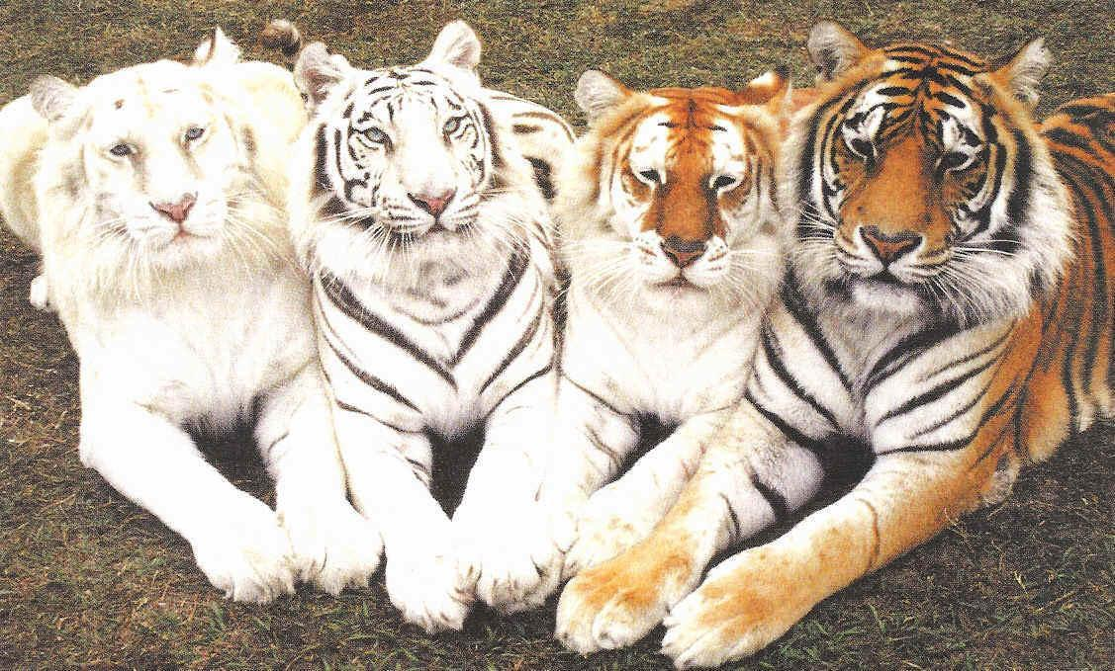

**Table of contents**

1 learn about the war

2 the war started

3 the tigers’ great attack

4 the lions are mad            5 the great battle

6 the lions’ **BIG   loss**

7 lions give up

8 the treaty

9 the treaty is broken

10 the lions’ even ***BIGGER*   LOSS**

11 the lions’ quick sneak attack

12 THE ***BIGGEST LOSS***

**Chapter 1 Learn about the war**

This is how the war started.  The lions made crazy rules; the main rule was you can only touch 2 trees in the forest.  All of the animals especially the tigers made a plan. It was to make the lions let the animals touch the trees.  When the tigers asked the lions they said, **“NO!”**  That was how the war started.

The tigers, foxes, and the wolves got ready for an attack.  The army of animals marched to the monkeys to get more men. When they were at the monkeys the tigers asked, “Can you help us defeat the lions?”  “Wabusy, “Said the monkeys.  At the lions the war begins.

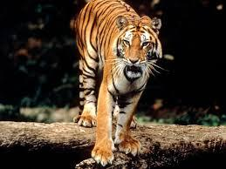

**Chapter 2 the War Started**

So the tigers got to the lion’s place.  They had a battle!

The lions won the battle.

The tigers were **MAD !**

The tigers won the next battle!

And it was bigger than the one that they loss!

The tigers had a party!

But it was a little one.

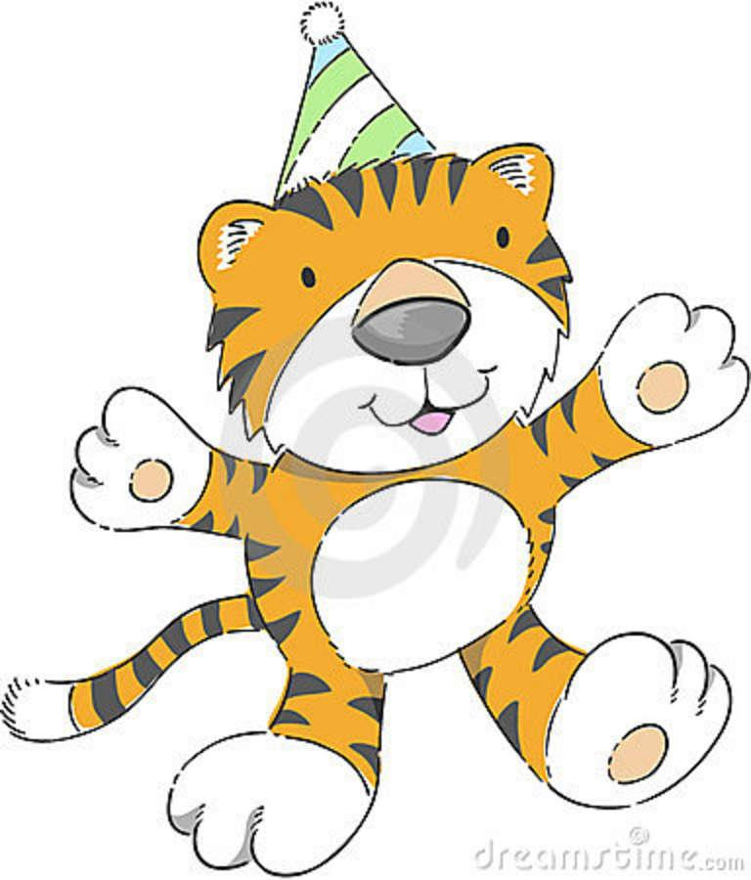

The other battles were close.  The tigers won 4 battles.

The lions won 3 battles.  But the lions won a little bigger battles.

The tigers and the lions did not use their best army.

**One** day the tigers where thinking of doing a big attack.

They came together to think and think.

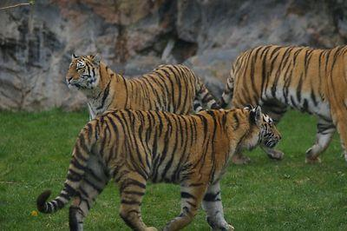

The tigers were practicing and practicing and they got ready with all of their tiger moves.  They sharpened their claws and got the general ready for all the attacks. He is practicing being a general.

Back at the lion’s den, they were thinking of a pretty good attack later.  They did the same thing as the tigers. They sharpened their claws and teeth and got ready.

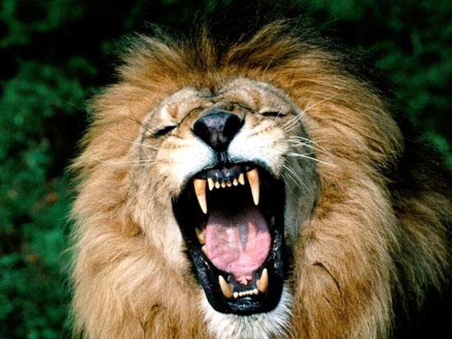

**Chapter 3 the Tigers’ Great Attack**

The lions thought they were going to attack north but they did `t

And the tigers attack south. It was not a close battle.

The tigers owned the lions. The lions were very mad.

The tigers were not ready for an attack.

The lions were getting ready for an attack. All of the lions were practicing for the attack.  All the tigers thought it was over but it was not over. The tigers told the monkeys we won the battle!

One tiger said to other tigers I think the lions are crying at the lions place and I think they are whining there too.

The lions had a plan it was when they have one of their parties and then they will attack them.

Chapter 4

THE LIONS WERE MAD

Their attack was a very big battle.  Lions won the fight. The tigers were very mad.

The lions had a big party. The king tiger guy was so mad.

The king lion was very happy. So after the battle the lions were going to attack the tigers again. The tigers were so mad they asked the monkeys can you help us. The monkeys said we are wabusy still.

Then a tiger said I think that is a no.

Chapter 5

The great battle

The tigers were going and they came through the lake.

The lions were going the same way. They both came together.

And they had a big battle. Well first the tigers were winning but then the lions came back.  And then the lions started to win by a lot. Then the tigers did not give up. So then the tigers started to win. And then they both ran away but the lions were pretending to go away but they came back.

So all the tigers wanted to beat the lions so much they went to the lion’s place but the lions were not running away; they were only pretending to run away.  And the tigers went to the lion’s place but nobody was there.

So the tigers were very confused. Well the tigers finally found out what the lions were doing.  They were pretending to go away. So the tigers found the lions. And they had a big battle. And it was a tie.  It was not a big battle; it was a small battle. 10 of each died. And then a tiger said we are still winning. But there was a lion spy that heard that tiger said that.  Well the lion spy reported to the king lion and the lion said we need to attack the tiger’s right actually in 15 minutes and we’re going to beat them.

CHAPTER 6

The lion’s big loss

But they found out about that.  They were right where the lion were going to stop. The lions lost big time. One lion gave up at the first second of the battle.

CHAPTER 7

The lions give up

The lions were losing so bad they gave up. The tigers had a big party and a parade!!!  The lions were so sad they never let anyone go out of the pack. The tigers made a rule that no one can pass the border.

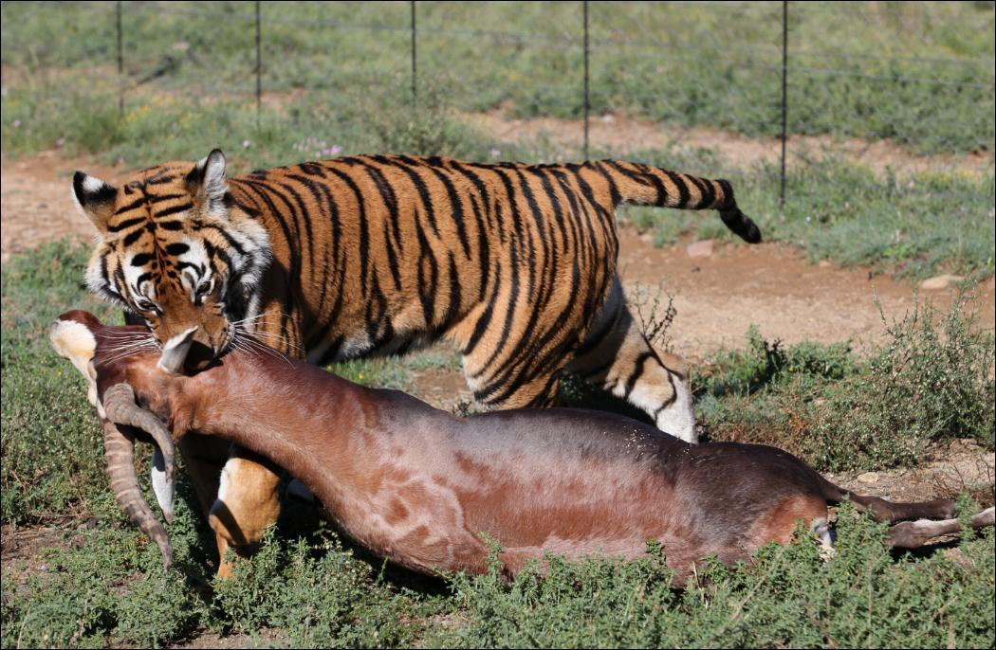

CHAPTER 8

THE TREATY

 THE LIONS AND THE TIGERS STILL CAN GO AND KILL EACH OTHER.

BUT ALL THE TIGERS SAID WAS WE WILL TRY TO KILL YOU IF YOU PASS THE BORDER.  SO THE TIGERS SAID DO YOU WANT TO HAVE A TREATY, AND THE LIONS SAID YES.

CHAPTER 9

 THE TREATY IS BROKEN

SO THE LIONS HAD A PLAN! THE PLAN WAS THAT THEY GO OVER TO THE TIGERS AND SAY WE ARE YOUR SLAVES AND THEN KILL THEM.

AND they killed a lot of tigers. And the tiger king declared war on the lions again.

Chapter 10

The lion’s bigger loss

The tiger sent 1000 tigers at the lions

The lions lost so bad; the pack was gone and the tigers destroyed it. The tigers killed 500 lions and the tigers thought all of lions died.  So they had a party.

And the lions were hiding while planning a sneak attack.

Chapter 11

The lion’s sneak attack

They were ready for the attack.  After the battle they took a lot of gaurds to thier place and they killed a lot of attackers.

Chapter 12

The lion’s biggest loss

The tigers sent 2000 tigers at the lions and all of the lions died.

The end…………………………….